INDEX

S. No. | Title | Page No
1 | Introduction
 | 1.1. Abstract
 | 1.2. Objectives
 | 1.3. Description of the System
 | 1.4. Proposed System & its Advantage
 | 1.5. Feasibility Study
 | 1.6. Exposed System
2 | System Analysis & Design
 | 2.1. System Design
 | 2.2. Table Structure
 | 2.3. System Testing & Analyzing
 | 2.4. Database Design
3 | System Requirements
 | 3.1. Hardware Requirements
 | 3.2. Software Requirements
4 | Front-end Application
 | 4.1. HTML5, CSS3
 | 4.2. Ajax
 | 4.3. J-Query, Bootstrap
5 | Backend Application
 | 5.1. PHP 5.7, JavaScript
 | 5.2. My-SQL 8, WampServer 2.0i
6 | Source Code & Project Screenshot
7 | Conclusion
8 | References Links & Bibliography

CHAPTER – 1

INTRODUCTION

  - ABSTRACT
The Complaint Management System is a web-based application developed using PHP and MySQL to efficiently manage and resolve customer complaints in an organized manner. The system provides a user-friendly interface where users can register, log in, and submit their complaints regarding products or services. Each complaint is stored in a centralized database, allowing administrators to track, update, and resolve issues systematically. The system includes different modules such as Admin and User. Users can view the status of their complaints, receive updates, and provide feedback. Administrators have the authority to categorize complaints, assign them to relevant departments, update statuses, and generate reports for analysis.
The main objective of this system is to improve customer satisfaction by ensuring timely response and resolution of complaints. It reduces manual work, enhances transparency, and maintains a proper record of all complaint-related activities. The use of PHP ensures dynamic web functionality, while MySQL provides a reliable and secure database for data management.
Overall, the system aims to streamline complaint handling processes and improve organizational efficiency through automation and better communication.
Project Name | Complaint Management System
Language Used | PHP5.6, PHP7.x
Database | MySQL 5.x
User Interface Design | HTML5, CSS3, AJAX,JQUERY,JAVASCRIPT
Web Browser | Mozilla, Google Chrome, IE8, OPERA
Software | XAMPP / Wamp / Lamp (anyone), Macromedia Dreamweaver 8

  - OBJECTIVES

The main objective of this project is to provide an efficient platform for
• To develop a web-based system for efficient handling and management of customer complaints.
• To provide a simple and user-friendly interface for users to register and submit complaints easily.

• To store and manage complaint data securely using a MySQL database.
• To enable administrators to track, update, and resolve complaints in a systematic manner.

• To improve communication between users and administrators through status updates and notifications.

• To reduce manual paperwork and minimize errors in complaint handling.

• To ensure transparency by allowing users to check the status of their complaints anytime.

• To generate reports and analytics for better decision-making and service improvement.

• To enhance overall customer satisfaction by providing timely responses and solutions.

  - DESCRIPTION OF THE SYSTEM

The Complaint Management System is a web-based application developed using PHP and MySQL that helps in managing and resolving customer complaints efficiently. The system allows users to register, log in, and submit their complaints through an online platform. Each complaint is stored in a centralized database, making it easy to track and manage.
The system consists of two main modules: User and Admin. Users can submit complaints, view their complaint history, and check the status of their issues. The Admin is responsible for reviewing complaints, categorizing them, assigning them to the appropriate department, updating their status, and resolving them.
The system ensures transparency by providing real-time updates to users and reduces manual work by automating the complaint handling process. It also maintains records of all complaints for future reference and analysis.
Overall, the system improves efficiency, reduces response time, and enhances customer satisfaction through organized complaint management.

  - PROPOSED SYSTEM & ITS ADVANTAGES

Proposed System:
The proposed system is a web-based Complaint Management System developed using PHP and MySQL that automates the process of registering, tracking, and resolving customer complaints. Users can submit complaints online, and administrators can manage, monitor, and resolve them through a centralized platform. The system provides real-time status updates and maintains a structured database of all complaints.
Advantages:
- Reduces manual work and paperwork.
- Provides quick and easy complaint registration.
- Enables efficient tracking and management of complaints.
- Improves transparency with real-time status updates.
- Ensures secure storage of complaint data.
- Enhances communication between users and administrators.
- Saves time and increases overall efficiency.
- Improves customer satisfaction through faster resolution.

  - FEASIBILITY STUDY

A feasibility study is an important step in system development that evaluates whether the proposed Complaint Management System is practical, achievable, and beneficial for implementation. It helps in analyzing different aspects such as technical, economic, operational, and time feasibility to ensure the success of the project.

1. Technical Feasibility
Technical feasibility focuses on the availability and capability of the required technology to develop and implement the system. The proposed system is developed using PHP for server-side scripting and MySQL for database management. These technologies are widely used, reliable, and supported on most platforms.
The system does not require any advanced hardware or specialized software, making it easy to deploy on standard computers or servers. Additionally, the development tools such as XAMPP or WAMP provide a suitable environment for building and testing the application. Therefore, the technical requirements are easily manageable, and the system is technically feasible.

2. Economic Feasibility
Economic feasibility analyzes the cost-effectiveness of the system. The proposed system is highly economical because it uses open-source technologies like PHP and MySQL, which do not require licensing costs.
The expenses involved are minimal, including basic hardware, internet connectivity, and possible hosting charges. Compared to manual systems, the automated system reduces labor costs, paperwork, and time consumption. In the long run, it increases productivity and efficiency, making it a cost-beneficial solution for organizations.

3. Operational Feasibility
Operational feasibility determines how well the system will work in a real-world environment. The proposed system is designed with a simple and user-friendly interface, making it easy for both users and administrators to operate.
Users can easily submit complaints and track their status, while administrators can manage and resolve complaints efficiently. The system improves communication, reduces delays, and ensures smooth workflow. Minimal training is required for users, making it highly practical for everyday operations.

4. Time Feasibility
Time feasibility evaluates whether the project can be completed within the given timeframe. Since the system is developed using simple and commonly used technologies, the development process is straightforward.
The project can be completed within a reasonable period, including planning, design, coding, testing, and implementation. Proper scheduling and resource management ensure timely completion of the project.

5. Legal Feasibility (Optional but Good to Add)
Legal feasibility ensures that the system complies with relevant laws and regulations. The proposed system does not violate any legal requirements, as it only handles complaint-related data. Proper measures can be taken to ensure data privacy and security, making the system legally acceptable.

  - EXPOSED SYSTEM
The existing system for handling complaints is mostly manual or semi-digital. Complaints are usually recorded through phone calls, emails, or written forms, which makes the process time-consuming and less organized. There is no centralized system to store and manage complaint data efficiently.
Tracking the status of complaints is difficult, and users often do not receive timely updates. This leads to delays in resolving issues and poor communication between customers and the organization. Additionally, maintaining records manually increases the chances of errors, data loss, and duplication.
Overall, the existing system lacks efficiency, transparency, and proper management, highlighting the need for an automated Complaint Management System.
The Exposed System refers to the overall structure and functionality of the proposed Complaint Management System that is accessible to users and administrators. It describes how the system is designed, how it interacts with users, and how different components work together to manage complaints effectively.
From the user perspective, the system exposes features such as registration, login, complaint submission, complaint history, and status tracking. Users can easily submit complaints by filling out a form and attaching necessary details. Once submitted, the complaint is stored in the database and assigned a unique identification number for tracking purposes.
From the administrator perspective, the system provides complete control over complaint management. Admins can view all complaints, categorize them based on type or priority, assign them to relevant departments or personnel, update the status (such as pending, in progress, or resolved), and communicate updates to users. The admin panel also includes reporting features to analyze complaint trends and performance.
The exposed system is designed to be user-friendly, efficient, and scalable. It can handle multiple users simultaneously and can be expanded in the future with additional features such as notifications, mobile access, or integration with other systems.

CHAPTER – 2

SYSTEM ANALYSIS & DESIGN
2.1. System Design

Systems analysis is the process by which an individual studies a system such that an information system can be analyzed, modelled, and a logical alternative can be chosen. Systems analysis projects are initiated for three reasons: problems, opportunities, and directives analysis is conducted for the purpose of studying a system or its parts in order to identify its objectives.

It is a problem solving technique that improves the system and ensures that all the components of the system work efficiently to accomplish their purpose. Analysis specifies what the system should do.
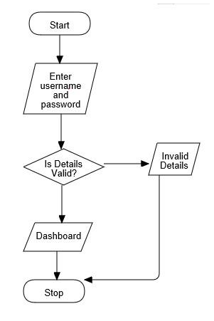

2.2. Table Design

Product prospective
It will be able to manage information about different tutorial in more user-friendly way. This system will manage tutorial information at various pages. User ID and password has been given to the entire field in admin accounts so that they can enter their see by this information to login from admin and.
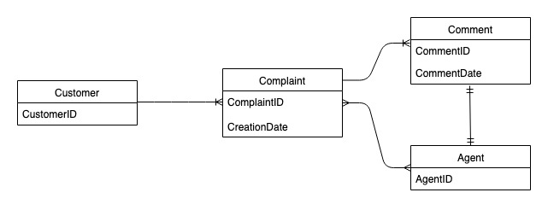
User Interface
- The system will be having user privileges-based menu.
- User will have to select the options form the given menu.
- The system will be selecting desire tutorial information from database.
- The forms will be designed to enter the data.
- Buttons will be used to insert, delete, clear and modify the data.
- Buttons to exit from the forms.

Class Diagram
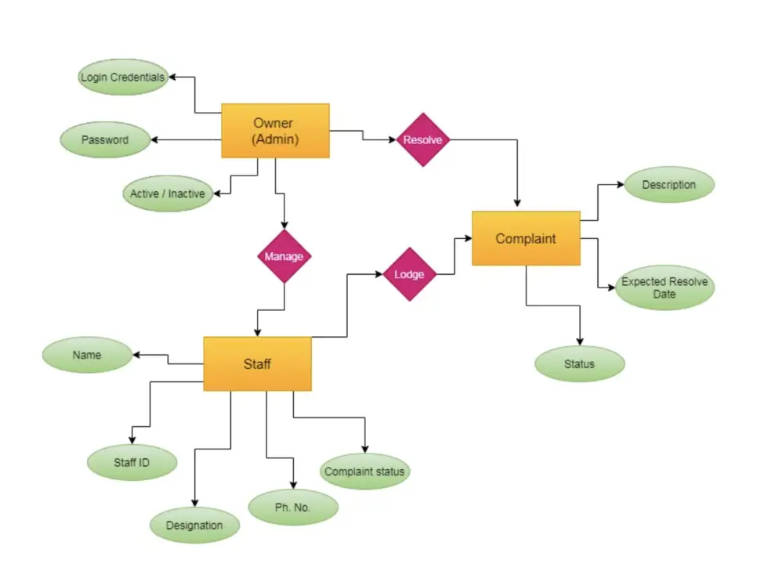

2.3. SYSTEM TESTING & ANALYZING

Objectives of Testing:
This section introduces the concept of testing and how important is, for the successful implementation of the project. Different phases of testing are described along with the level of testing incorporated in this particular project.
Testing is vital to the success of any system. Testing is done at different stages within the phase. System testing makes a logical assumption that if all phases of the system are correct, the goals will be achieved successfully. Inadequate testing at all leads to errors that may come up after a long time when correction would be extremely difficult. Another objective of testing is its utility as a user- oriented vehicle before implementation. The testing of the system was done on both artificial and live data.

Testing involves operation of a system or application under controlled conditions and evaluating the results (e.g., “if the user is in interface A of the application while using hardware B and does C, then D should not happen”). The controlled conditions should include both normal and abnormal conditions.
Typically, the project team includes a mix of testers and developers who work closely together, with the overall QA processes being monitored by the project managers.
Testing principles
Davis suggested a set of testing principles in 1995. These are:
1) All tests should be traceable to the customer requirements.
2) Test should be planned long before testing begins.
3) Testing should begin in small and progressed towards testing in the large.
4) Exhaustive testing is not possible.
5) For effective results, testing should be conducted by an independent third party.

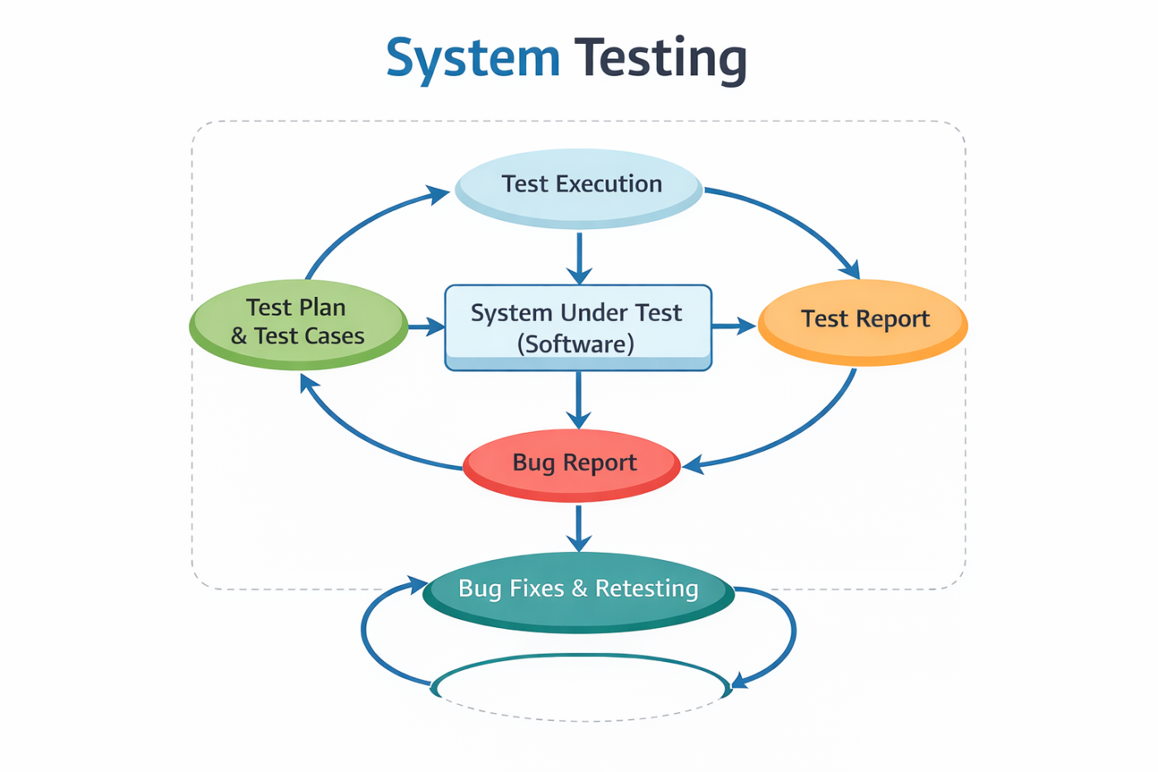

Types of Testing
Black Box Testing
Also known as functional testing, this is a software testing technique whereby the tester does not know the internal working of the item being tested. Black- box test design treats the system as a “black-box”, so it does not explicitly use knowledge of the internal structure. Black-box test design is usually described as focusing on testing functional requirements. Synonyms for black-box includes: behavioural, functional, opaque-box and closed-box.

White Box Testing
White box test design allows one to peek inside the “box”, and it focuses specifically on using internal knowledge of the software to guide the selection of test data. Synonyms for white-box include: structural, glass-box and clear- box.

Condition Testing
An improvement over White-box testing, the process of condition testing ensures that a controlling expression has been adequately exercised whist the software is under test by constructing a constraint set for every expression and then ensuring that every member on the constraint set is included in the values whish are presented to the expression.
Data Life-Cycle Testing
It is based upon the consideration that in the software code, a variable is at some stage created, and subsequently may have its value changed or used in a controlling expression several times before being destroyed. If only locally declared Boolean used in control conditions are considered then an examination of the sources code will indicate the place in the source code where the variable is created, places where it is given a value is used as a part of a control expression and the place where it is destroyed.
This approach to testing requires all possible feasible lifecycles of the variable to be covered whilst the module is under test.
Unit Testing
The purpose of this phase is to test the individual units of the developing software component. This phase is recursive and is to be repeated, as many as there are, levels of testing. In the DGLW project, each individual form has been tested using techniques of testing namely: Client-side testing using JavaScript.
Each individual form has been validated so that user enters only valid data at every time.
Functional Testing:
This is done for each module / sub module of the system. Functional testing serves as a means of validating whether the functionality of the system Confers the original user requirement i.e. does the module do what it was supposed to do? Separate schedules were made for functional testing. It involves preparation of the test data, writing of test cases, testing for conformance to test cases and preparation of bugs listing for non-conformities.
System Testing:
System testing is done when the entire system has been fully integrated. The purpose of the system testing is to test how the different modules interact with each other and whether the entire system provides the functionality that was expected.
System testing consists of the following steps:
a) Program Testing
b) String Testing
c) System Testing
d) System Documentation
e) User Acceptance Testing

2.4. DATABASE DESIGN

The data in the system has to be stored and retrieved from database. Designing the database is part of system design. Data elements and data structures to be stored have been identified at analysis stage. They are structured and put together to design the data storage and retrieval system.

A database is a collection of interrelated data stored with minimum redundancy to serve many users quickly and efficiently. The general objective is to make database access easy, quick, inexpensive and flexible for the user. Relationships are established between the data items and unnecessary data items are removed. Normalization is done to get an internal consistency of data and to have minimum redundancy and maximum stability. This ensures minimizing data storage required, minimizing chances of data inconsistencies and optimizing for updates. The MySQL database has been chosen for developing the relevant databases.

CLIENT-SIDESERVER
DATABASE
DATABASE
DATABASE
ADMINSERVER

CHAPTER – 3

SYSTEM REQUIREMENTS
Software Specifications

The requirement analysis stage of a software engineering project involves collecting and analysing information about the part of the organization that is supported by the application.
- Hardware Requirements
- Software Requirements

3.1. Hardware Requirements
- Intel Pentium 4 processor
- 80GB hard disk
- 1GB RAM
- OS: Windows XP/ Windows 7
- Internet Usage 4.2MBPS

3.2. Software Requirements
- HTML5
- CSS3
- PHP (Advanced Version – Core)
- JavaScript
- J-Query
- My-SQL
- Apache
- Macromedia Dreamweaver CS6
- WampServer 2.0i

CHAPTER – 4

FRONT-END APPLICATION
  - HTML5 & CSS3

HTML stands for Hyper Text Mark-up Language. HTML5 is a revised version of the original HTML standard created in 1990 by the World Wide Web Consortium to define an Open Web Platform. HTML is a language used for structuring and presenting content on the Web consistently, across web browsers. HTML5 is the evolution of that standard to meet the increasing demands presented by today’s rich media, cross device and mobile internet access requirements. As such, it is a great candidate for cross-platform mobile application development, as many of its features have been adapted with the consideration of running on low powered devices, such as Smart Phones and Tablets and providing web developers with tools like CSS3. Importantly whilst running within a web browser, (as HTML5 does) it is not tied to the underlying operating system, freeing applications from the significant development and support overhead of multiple native applications (e.g. iOS, Android, Blackberry etc.)

Cascading Style Sheets (CSS)
CSS stands for ‘Cascading Style Sheets’ and is the language of design for web pages, giving site designers the ability to suggest how their site documents are styled. CSS is interpreted by all graphical web browsers regardless of device or operating system. It allows a logical division between the structure of a web page, (handled by the HTML) and the way it should look. CSS can be used to tailor the appearance of a web page specific to a particular device or screen size. In short, CSS is the language used for implementing front-end web design.
Advantages of HTML5 and CSS
Using HTML5 and CSS3 provides advantages to businesses that develop and deploy web content and web applications, to create refined and accurate web pages and web systems that operate across devices, operating systems and web browsers. Write once, run anywhere. The plethora of devices, operating systems and screen sizes present numerous designs, functional and layout considerations and problems if standards are not adhered to.

  - AJAX

What is AJAX?
AJAX = Asynchronous JavaScript And XML.
AJAX is not a programming language.
AJAX just uses a combination of:
- A browser built-in XMLHttpRequest object (to request data from a web server)
- JavaScript and HTML DOM (to display or use the data)
AJAX is a misleading name. AJAX applications might use XML to transport data, but it is equally common to transport data as plain text or JSON text.
AJAX allows web pages to be updated asynchronously by exchanging data with a web server behind the scenes. This means that it is possible to update parts of a web page, without reloading the whole page.
  - J-Query & Bootstrap

J-Query
jQuery is a fast, small, and feature-rich JavaScript library. It makes things like HTML document traversal and manipulation, event handling, animation, and Ajax much simpler with an easy-to-use API that works across a multitude of browsers. With a combination of versatility and extensibility, jQuery has changed the way that millions of people write JavaScript.

Getting started with jQuery can be easy or challenging, depending on your experience with JavaScript, HTML, CSS, and programming concepts in general. In addition to these articles, you can read about the history of jQuery and the licensing terms that apply to jQuery projects. You can also make a donation to help the jQuery team continue to improve jQuery.

One important thing to know is that jQuery is just a JavaScript library. All the power of jQuery is accessed via JavaScript, so having a strong grasp of JavaScript is essential for understanding, structuring, and debugging your code. While working with jQuery regularly can, over time, improve your proficiency with JavaScript, it can be hard to get started writing jQuery without a working knowledge of JavaScript's built-in constructs and syntax. Therefore, if you're new to JavaScript, we recommend checking out the JavaScript basics tutorial on the Mozilla Developer Network (MDN).
Bootstrap
Bootstrap is the most popular CSS Framework for developing responsive and mobile-first websites.
Bootstrap 5 is the newest version of Bootstrap

Bootstrap is a free, open source front-end development framework for the creation of websites and web apps. Designed to enable responsive development of mobile-first websites, Bootstrap provides a collection of syntax for template designs.

As a framework, Bootstrap includes the basics for responsive web development, so developers only need to insert the code into a pre-defined grid system. The Bootstrap framework is built on Hypertext Markup Language (HTML), cascading style sheets (CSS) and JavaScript. Web developers using Bootstrap can build websites much faster without spending time worrying about basic commands and functions.

Bootstrap development framework
Bootstrap's 12-column grid system can update responsively based on screen size.
What is Bootstrap used for?
Bootstrap makes responsive web design a reality. It makes it possible for a web page or app to detect the visitor's screen size and orientation and automatically adapt the display accordingly. The mobile-first approach assumes smartphones, tablets and task-specific mobile apps are employees' primary tools for getting work done. Bootstrap addresses the requirements of those technologies in design and includes UI components, layouts, JavaScript tools and the implementation framework.
What is bootstrap in a computer?
In computing, the term bootstrap means to boot or to load a program into a computer using a much smaller initial program to load in the desired program, which is usually an OS.

CHAPTER – 5

BACK-END APPLICATION
  - PHP & JAVASCRIPT

PHP:
Hypertext Pre-processor (PHP) is a programming language that allows web developers to create dynamic content that interacts with databases.
PHP is basically used for developing web-based software applications. This tutorial helps you to build your base with PHP.
PHP started out as a small open source project that evolved as more and more people found out how useful it was. Rasmus Lerdorf unleashed the first version of PHP way back in 1994.
• PHP is a recursive acronym for "PHP: Hypertext Pre-processor".
• PHP is a server-side scripting language that is embedded in HTML. It is used to manage dynamic content, databases, session tracking, even build entire e-commerce sites.
• It is integrated with a number of popular databases, including MySQL, PostgreSQL, Oracle, Sybase, Informix, and Microsoft SQL Server.
• PHP is pleasingly zippy in its execution, especially when compiled as an Apache module on the Unix side. The MySQL server, once started, executes even very complex queries with huge result sets in record- setting time.
• PHP supports a large number of major protocols such as POP3, IMAP, and LDAP. PHP4 added support for Java and distributed object architectures (COM and CORBA), making n-tier development a possibility for the first time.
• PHP is forgiving: PHP language tries to be as forgiving as possible.
• PHP Syntax is C-Like.
Common uses of PHP:
• PHP performs system functions, i.e. from files on a system it can create, open, read, write, and close them.
• PHP can handle forms, i.e. gather data from files, save data to a file, thru email you can send data, return data to the user.
• You add, delete, and modify elements within your database thru PHP.
• Access cookies variables and set cookies.
• Using PHP, you can restrict users to access some pages of your website.
• It can encrypt data.
Characteristics of PHP
Five important characteristics make PHP's practical nature possible:
• Simplicity
• Efficiency
• Security
• Flexibility
• Familiarity

JavaScript:
JavaScript is a simple, powerful, and popular programming language that is built into web browsers. Learning JavaScript is especially useful if you are a web designer and already know HTML and CSS, because it is used to make web pages interactive. However, JavaScript is not limited to making interactive web pages; you can also use it for server-side programming using a framework like Node.js.
In this tutorial you'll learn some JavaScript basics, including two basic computer programming concepts—calculations and variables. If you want to learn to make interactive websites using JavaScript, you need to learn core computer programming concepts. Using HTML and JavaScript, you can change the contents of HTML elements in response to user events, such as a button click.

Writing a simple Hello World JavaScript program
JavaScript programs are a sequence of statements or commands that are run by a web browser in the order they are written. The simplest JavaScript program can be a single line long, while large programs can be thousands of lines long. The computer programming tradition is that the first program you learn is one that outputs the message: Hello World. The code below is an example of a JavaScript Hello World program wrapped in a few lines of HTML, which enables it to run in a web browser as a valid web page.

  - MY-SQL

MySQL, pronounced either "My S-Q-L" or "My Sequel," is an open source relational database management system. It is based on the structure query language (SQL), which is used for adding, removing, and modifying information in the database. Standard SQL commands, such as ADD, DROP, INSERT, and UPDATE can be used with MySQL.
MySQL can be used for a variety of applications, but is most commonly found on Web servers. A website that uses MySQL may include Web pages that access information from a database. These pages are often referred to as "dynamic," meaning the content of each page is generated from a database as the page loads. Websites that use dynamic Web pages are often referred to as database-driven websites.
Many database-driven websites that use MySQL also use a Web scripting language like PHP to access information from the database. MySQL commands can be incorporated into the PHP code, allowing part or all of a Web page to be generated from database information. Because both MySQL and PHP are both open source (meaning they are free to download and use), the PHP/MySQL combination has become a popular choice for database-driven websites.

WampServer
WampServer installs automatically all you need to start developing web applications and is very intuitive to use. You will be able to tune your server without even touching the setting files.
INSTALLING
• Double click on the downloaded file and just follow the instructions. Everything is automatic. The WampServer package is delivered with the latest releases of Apache, MySQL and PHP.
• Once WampServer is installed, you can add other releases by downloading them on this website. They will then appear in the WampServer menu and you will be able to switch releases with a simple click.
• Each release of Apache, MySQL and PHP has its own settings and its own files (datas for MySQL).
Using WampServer
• The “www” directory will be automatically created (usually c:\wamp\www)
• Create a subdirectory in “www” and put your PHP files inside.
• Click on the “localhost” link in the WampServer menu or open your internet
browser and go to the URL: http://localhost
WampServer’s functionalities are very complete and easy to use so we won’t
explain here how to use them.
With a left click on WampServer’s icon, you will be able to:
• manage your Apache and MySQL services
• switch online/offline (give access to everyone or only localhost)
• install and switch Apache, MySQL and PHP releases
• manage your servers’ settings
• access your settings files & create alias
With a right click:
• change WampServer’s menu language
• access this page

CHAPTER – 6

SOURCE CODE & PROJECT SCREENSHOT
6.1. SOURCE CODE

- dbconnection.php

<?php
$con=mysqli_connect("Localhost", "root", "", "librarydb");
if(mysqli_connect_errno()){
echo "Connection Fail".mysqli_connect_error();
}

?>
- index.php

<?php
session_start();
error_reporting(0);
include('includes/config.php');
if($_SESSION['login']!=''){
$_SESSION['login']='';
}
if(isset($_POST['login']))
{

$email=$_POST['emailid'];
$password=md5($_POST['password']);
$sql ="SELECT EmailId,Password,StudentId,Status FROM tblstudents WHERE EmailId=:email and Password=:password";
$query= $dbh -> prepare($sql);
$query-> bindParam(':email', $email, PDO::PARAM_STR);
$query-> bindParam(':password', $password, PDO::PARAM_STR);
$query-> execute();
$results=$query->fetchAll(PDO::FETCH_OBJ);

if($query->rowCount() > 0)
{
foreach ($results as $result) {
$_SESSION['stdid']=$result->StudentId;
if($result->Status==1)
{
$_SESSION['login']=$_POST['emailid'];
echo "<script type='text/javascript'> document.location ='dashboard.php'; </script>";
} else {
echo "<script>alert('Your Account Has been blocked .Please contact admin');</script>";

}
}

}

else{
echo "<script>alert('Invalid Details');</script>";
}
}

?>
<!DOCTYPE html>
<html xmlns="http://www.w3.org/1999/xhtml">
<head>
<meta charset="utf-8" />
<meta name="viewport" content="width=device-width, initial-scale=1, maximum-scale=1" />
<meta name="description" content="" />
<meta name="author" content="" />
<title>Online Library Management System | </title>
<!-- BOOTSTRAP CORE STYLE -->
<link href="assets/css/bootstrap.css" rel="stylesheet" />
<!-- FONT AWESOME STYLE -->
<link href="assets/css/font-awesome.css" rel="stylesheet" />
<!-- CUSTOM STYLE -->
<link href="assets/css/style.css" rel="stylesheet" />
<!-- GOOGLE FONT -->
<link href='http://fonts.googleapis.com/css?family=Open+Sans' rel='stylesheet' type='text/css' />

</head>
<body>
<!------MENU SECTION START-->
<?php include('includes/header.php');?>
<!-- MENU SECTION END-->
<div class="content-wrapper">
<div class="container">
<!--Slider---->
<div class="row">
<div class="col-md-10 col-sm-8 col-xs-12 col-md-offset-1">
<div id="carousel-example" class="carousel slide slide-bdr" data-ride="carousel" >
<div class="carousel-inner">
<div class="item active">
<img src="assets/img/1.jpg" alt="" />
</div>
<div class="item">
<img src="assets/img/2.jpg" alt="" />
</div>
<div class="item">
<img src="assets/img/3.jpg" alt="" />
</div>
</div>
<!--INDICATORS-->
<ol class="carousel-indicators">
<li data-target="#carousel-example" data-slide-to="0" class="active"></li>
<li data-target="#carousel-example" data-slide-to="1"></li>
<li data-target="#carousel-example" data-slide-to="2"></li>
</ol>
<!--PREVIUS-NEXT BUTTONS-->
<a class="left carousel-control" href="#carousel-example" data-slide="prev">
<span class="glyphicon glyphicon-chevron-left"></span>
</a>
<a class="right carousel-control" href="#carousel-example" data-slide="next">
<span class="glyphicon glyphicon-chevron-right"></span>
</a>
</div>
</div>
</div>
<hr />

<div class="row pad-botm">
<div class="col-md-12">
<h4 class="header-line">USER LOGIN FORM</h4>
</div>
</div>
<a name="ulogin"></a>
<!--LOGIN PANEL START-->
<div class="row">
<div class="col-md-6 col-sm-6 col-xs-12 col-md-offset-3" >
<div class="panel panel-info">
<div class="panel-heading">
LOGIN FORM
</div>
<div class="panel-body">
<form role="form" method="post">

<div class="form-group">
<label>Enter Email id</label>
<input class="form-control" type="text" name="emailid" required autocomplete="off" />
</div>
<div class="form-group">
<label>Password</label>
<input class="form-control" type="password" name="password" required autocomplete="off" />
<p class="help-block"><a href="user-forgot-password.php">Forgot Password</a></p>
</div>

<button type="submit" name="login" class="btn btn-info">LOGIN </button> | <a href="signup.php">Not Register Yet</a>
</form>
</div>
</div>
</div>
</div>
<!---LOGIN PABNEL END-->

</div>
</div>
<!-- CONTENT-WRAPPER SECTION END-->
<?php include('includes/footer.php');?>
<!-- FOOTER SECTION END-->
<script src="assets/js/jquery-1.10.2.js"></script>
<!-- BOOTSTRAP SCRIPTS -->
<script src="assets/js/bootstrap.js"></script>
<!-- CUSTOM SCRIPTS -->
<script src="assets/js/custom.js"></script>

</body>
</html>

- signup.php

<?php
session_start();
include('includes/config.php');
error_reporting(0);
if(isset($_POST['signup']))
{

//Code for student ID
$count_my_page = ("studentid.txt");
$hits = file($count_my_page);
$hits[0] ++;
$fp = fopen($count_my_page , "w");
fputs($fp , "$hits[0]");
fclose($fp);
$StudentId= $hits[0];
$fname=$_POST['fullanme'];
$mobileno=$_POST['mobileno'];
$email=$_POST['email'];
$password=md5($_POST['password']);
$status=1;
$sql="INSERT INTO tblstudents(StudentId,FullName,MobileNumber,EmailId,Password,Status) VALUES(:StudentId,:fname,:mobileno,:email,:password,:status)";
$query = $dbh->prepare($sql);
$query->bindParam(':StudentId',$StudentId,PDO::PARAM_STR);
$query->bindParam(':fname',$fname,PDO::PARAM_STR);
$query->bindParam(':mobileno',$mobileno,PDO::PARAM_STR);
$query->bindParam(':email',$email,PDO::PARAM_STR);
$query->bindParam(':password',$password,PDO::PARAM_STR);
$query->bindParam(':status',$status,PDO::PARAM_STR);
$query->execute();
$lastInsertId = $dbh->lastInsertId();
if($lastInsertId)
{
echo '<script>alert("Your Registration successfull and your student id is "+"'.$StudentId.'")</script>';
}
else
{
echo "<script>alert('Something went wrong. Please try again');</script>";
}
}

?>

<!DOCTYPE html>
<html xmlns="http://www.w3.org/1999/xhtml">
<head>
<meta charset="utf-8" />
<meta name="viewport" content="width=device-width, initial-scale=1, maximum-scale=1" />
<meta name="description" content="" />
<meta name="author" content="" />
<!--[if IE]>
<meta http-equiv="X-UA-Compatible" content="IE=edge,chrome=1">
<![endif]-->
<title>Online Library Management System | Student Signup</title>
<!-- BOOTSTRAP CORE STYLE -->
<link href="assets/css/bootstrap.css" rel="stylesheet" />
<!-- FONT AWESOME STYLE -->
<link href="assets/css/font-awesome.css" rel="stylesheet" />
<!-- CUSTOM STYLE -->
<link href="assets/css/style.css" rel="stylesheet" />
<!-- GOOGLE FONT -->
<link href='http://fonts.googleapis.com/css?family=Open+Sans' rel='stylesheet' type='text/css' />
<script type="text/javascript">
function valid()
{
if(document.signup.password.value!= document.signup.confirmpassword.value)
{
alert("Password and Confirm Password Field do not match !!");
document.signup.confirmpassword.focus();
return false;
}
return true;
}
</script>
<script>
function checkAvailability() {
$("#loaderIcon").show();
jQuery.ajax({
url: "check_availability.php",
data:'emailid='+$("#emailid").val(),
type: "POST",
success:function(data){
$("#user-availability-status").html(data);
$("#loaderIcon").hide();
},
error:function (){}
});
}
</script>

</head>
<body>
<!------MENU SECTION START-->
<?php include('includes/header.php');?>
<!-- MENU SECTION END-->
<div class="content-wrapper">
<div class="container">
<div class="row pad-botm">
<div class="col-md-12">
<h4 class="header-line">User Signup</h4>

</div>

</div>
<div class="row">

<div class="col-md-9 col-md-offset-1">
<div class="panel panel-danger">
<div class="panel-heading">
SINGUP FORM
</div>
<div class="panel-body">
<form name="signup" method="post" onSubmit="return valid();">
<div class="form-group">
<label>Enter Full Name</label>
<input class="form-control" type="text" name="fullanme" autocomplete="off" required />
</div>

<div class="form-group">
<label>Mobile Number :</label>
<input class="form-control" type="text" name="mobileno" maxlength="10" autocomplete="off" required />
</div>

<div class="form-group">
<label>Enter Email</label>
<input class="form-control" type="email" name="email" id="emailid" onBlur="checkAvailability()" autocomplete="off" required />
<span id="user-availability-status" style="font-size:12px;"></span>
</div>

<div class="form-group">
<label>Enter Password</label>
<input class="form-control" type="password" name="password" autocomplete="off" required />
</div>

<div class="form-group">
<label>Confirm Password </label>
<input class="form-control" type="password" name="confirmpassword" autocomplete="off" required />
</div>

<button type="submit" name="signup" class="btn btn-danger" id="submit">Register Now </button>

</form>
</div>
</div>
</div>
</div>
</div>
</div>
<!-- CONTENT-WRAPPER SECTION END-->
<?php include('includes/footer.php');?>
<script src="assets/js/jquery-1.10.2.js"></script>
<!-- BOOTSTRAP SCRIPTS -->
<script src="assets/js/bootstrap.js"></script>
<!-- CUSTOM SCRIPTS -->
<script src="assets/js/custom.js"></script>
</body>
</html>
- complaint_details.php
<?php
session_start();
include('include/config.php');
if(strlen($_SESSION['aid'])==0)
{
header('location:index.php');
}
else{
date_default_timezone_set('Asia/Kolkata');// change according timezone
$currentTime = date( 'd-m-Y h:i:s A', time () );

?>
<!DOCTYPE html>
<html lang="en">

<head>
<title>CMS|| Complaints Details</title>

<!-- vendor css -->
<link rel="stylesheet" href="assets/css/style.css">

<script language="javascript" type="text/javascript">
var popUpWin=0;
function popUpWindow(URLStr, left, top, width, height)
{
if(popUpWin)
{
if(!popUpWin.closed) popUpWin.close();
}
popUpWin = open(URLStr,'popUpWin', 'toolbar=no,location=no,directories=no,status=no,menubar=no,scrollbars=yes,resizable=no,copyhistory=yes,width='+600+',height='+600+',left='+left+', top='+top+',screenX='+left+',screenY='+top+'');
}

</script>

</head>
<body class="">
<?php include('include/sidebar.php');?>
<!-- [ navigation menu ] end -->
<!-- [ Header ] start -->
<?php include('include/header.php');?>

<!-- [ Main Content ] start -->
<section class="pcoded-main-container">
<div class="pcoded-content">
<!-- [ breadcrumb ] start -->
<div class="page-header">
<div class="page-block">
<div class="row align-items-center">
<div class="col-md-12">
<div class="page-header-title">
<h5 class="m-b-10">Complaints Details</h5>
</div>
<ul class="breadcrumb">
<li class="breadcrumb-item"><a href="dashboard.php"><i class="feather icon-home"></i></a></li>
<li class="breadcrumb-item"><a href="all-complaint.php">Complaints Details</a></li>

</ul>
</div>
</div>
</div>
</div>
<!-- [ breadcrumb ] end -->
<!-- [ Main Content ] start -->
<div class="row">

<!-- [ form-element ] start -->
<div class="col-sm-12">
<div class="card">

<div class="card-body">
<h5>View Complaints Details</h5>
<hr>

<div class="row">
<div class="col-xl-12">
<div class="card">

<div class="card-body table-border-style">
<div class="table-responsive">
<table class="table table-bordered">
<thead>

</thead>
<tbody>
<?php $st='closed';
$cid=$_GET['cid'];
$query=mysqli_query($con,"select tblcomplaints.*,users.fullName as name,category.categoryName as catname from tblcomplaints join users on users.id=tblcomplaints.userId join category on category.id=tblcomplaints.category where tblcomplaints.complaintNumber='$cid'");
while($row=mysqli_fetch_array($query))
{

?>
<tr>
<td><b>Complaint Number</b></td>
<td><?php echo htmlentities($row['complaintNumber']);?></td>
<td><b>Complainant Name</b></td>
<td> <?php echo htmlentities($row['name']);?></td>
<td><b>Reg Date</b></td>
<td><?php echo htmlentities($row['regDate']);?>
</td>
</tr>

<tr>
<td><b>Category </b></td>
<td><?php echo htmlentities($row['catname']);?></td>
<td><b>SubCategory</b></td>
<td> <?php echo htmlentities($row['subcategory']);?></td>
<td><b>Complaint Type</b></td>
<td><?php echo htmlentities($row['complaintType']);?>
</td>
</tr>
<tr>
<td><b>State </b></td>
<td><?php echo htmlentities($row['state']);?></td>
<td ><b>Nature of Complaint</b></td>
<td colspan="3"> <?php echo htmlentities($row['noc']);?></td>

</tr>
<tr>
<td><b>Complaint Details </b></td>

<td colspan="5"> <?php echo htmlentities($row['complaintDetails']);?></td>

</tr>

</tr>
<tr>
<td><b>File(if any) </b></td>

<td colspan="5"> <?php $cfile=$row['complaintFile'];
if($cfile=="" || $cfile=="NULL")
{
echo "File NA";
}
else{?>
<a href="../users/complaintdocs/<?php echo htmlentities($row['complaintFile']);?>" target="_blank"/> View File</a>
<?php } ?></td>
</tr>

<tr>
<td><b>Final Status</b></td>

<td colspan="5"> <?php $status=$row['status'];
if($status==''): ?>
<span class="badge badge-danger">Not Processed Yet</span>
<?php elseif($status=='in process'):?>
<span class="badge badge-warning">In Process</span>
<?php elseif($status=='closed'):?>
<span class="badge badge-success">Closed</span>
<?php endif;?></td>

</tr>
<hr>

<?php $ret=mysqli_query($con,"select complaintremark.remark as remark,complaintremark.status as sstatus,complaintremark.remarkDate as rdate from complaintremark join tblcomplaints on tblcomplaints.complaintNumber=complaintremark.complaintNumber where complaintremark.complaintNumber='$cid'");
$cnt=1;
$count=mysqli_num_rows($ret);
if($count): ?>
<tr>
<th>S.No</th>
<th colspan="3">Remark</th>
<th>Status</th>
<th>Updation Date</th>
</tr>
<?php
while($rw=mysqli_fetch_array($ret))
{
?>
<tr>
<td><?php echo htmlentities($cnt);?></td>
<td colspan="3"><?php echo htmlentities($rw['remark']); ?></td>
<td><?php echo htmlentities($rw['sstatus']); ?></td>
<td><?php echo htmlentities($rw['rdate']); ?></td></tr><?php $cnt=$cnt+1; } endif; ?>

<tr>
<td>
<?php if($row['status']=="closed"){

} else {?>
<a href="javascript:void(0);" onClick="popUpWindow('updatecomplaint.php?cid=<?php echo htmlentities($row['complaintNumber']);?>');" title="Update order">
<button type="button" class="btn btn-primary">Take Action</button></td>
</a><?php } ?></td>
<td colspan="4">
<a href="javascript:void(0);" onClick="popUpWindow('userprofile.php?uid=<?php echo htmlentities($row['userId']);?>');" title="Update order">
<button type="button" class="btn btn-primary">View User Detials</button></a></td>

</tr>
<?php } ?>

</tbody>
</table>
</div>
</div>
</div>
</div>

</div>

</div>
</div>

</div>
<!-- [ form-element ] end -->
</div>
<!-- [ Main Content ] end -->

</div>
</section>
<!-- Required Js -->
<script src="assets/js/vendor-all.min.js"></script>
<script src="assets/js/plugins/bootstrap.min.js"></script>
<script src="assets/js/pcoded.min.js"></script>
</body>
</html>
<?php } ?>
- dashboard.php
<?php session_start();
//error_reporting(0);
include('include/config.php');
if(strlen($_SESSION['alogin'])==0)
{
header('location:index.php');
}
else{
?>
<!DOCTYPE html>
<html lang="en">

<head>
<title>Complaint Management System || Dashboard</title>
<link rel="stylesheet" href="assets/css/style.css">
</head>
<body class="">
<!-- [ Pre-loader ] start -->
<?php include('include/sidebar.php');?>
<!-- [ navigation menu ] end -->
<!-- [ Header ] start -->
<?php include('include/header.php');?>
<!-- [ Header ] end -->

<!-- [ Main Content ] start -->
<div class="pcoded-main-container">
<div class="pcoded-content">
<!-- [ breadcrumb ] start -->
<div class="page-header">
<div class="page-block">
<div class="row align-items-center">
<div class="col-md-12">
<div class="page-header-title">
<h5 class="m-b-10">Dashboard Analytics</h5>
</div>
<ul class="breadcrumb">
<li class="breadcrumb-item"><a href="dashboard.php"><i class="feather icon-home"></i></a></li>
<li class="breadcrumb-item"><a href="#!">Dashboard Analytics</a></li>
</ul>
</div>
</div>
</div>
</div>
<!-- [ breadcrumb ] end -->
<!-- [ Main Content ] start -->
<div class="row">
<!-- table card-1 start -->
<div class="col-md-12 col-xl-4">

<!-- widget primary card start -->
<div class="card flat-card widget-primary-card">
<div class="row-table">
<div class="col-sm-3 card-body">
<i class="feather icon-users"></i>
</div>
<div class="col-sm-9">
<?php $query1=mysqli_query($con,"select id from users");
$totusers=mysqli_num_rows($query1);
?>
<h4><?php echo $totusers;?></h4>
<a href="manage-users.php"><h6>Total Users</h6></a>
</div>
</div>
</div>
<!-- widget primary card end -->
</div>
<!-- table card-1 end -->
<!-- table card-2 start -->
<div class="col-md-12 col-xl-4">

<!-- widget-success-card start -->
<div class="card flat-card bg-warning">
<div class="row-table">
<div class="col-sm-3 card-body">
<i class="fas fa-file"></i>
</div>
<div class="col-sm-9">
<?php $query2=mysqli_query($con,"select id from category");
$totcategory=mysqli_num_rows($query2);
?>
<h4><?php echo $totcategory;?></h4>
<a href="category.php"><h6>Total Category</h6></a>
</div>
</div>
</div>
<!-- widget-success-card end -->
</div>
<div class="col-md-12 col-xl-4">

<!-- widget-success-card start -->
<div class="card flat-card widget-purple-card">
<div class="row-table">
<div class="col-sm-3 card-body">
<i class="fas fa-file"></i>
</div>
<div class="col-sm-9">
<?php $query3=mysqli_query($con,"select id from subcategory");
$totsubcategory=mysqli_num_rows($query3);
?>
<h4><?php echo $totsubcategory;?></h4>
<a href="subcategory.php"><h6>Total Subcategory</h6></a>
</div>
</div>
</div>
<!-- widget-success-card end -->
</div>
<!-- table card-2 end -->
<div class="col-md-12 col-xl-4">

<!-- widget-success-card start -->
<div class="card flat-card bg-primary">
<div class="row-table">
<div class="col-sm-3 card-body">
<i class="fas fa-globe"></i>
</div>
<div class="col-sm-9">
<?php $query4=mysqli_query($con,"select id from state");
$totstate=mysqli_num_rows($query4);
?>
<h4><?php echo $totstate;?></h4>
<a href="state.php"><h6>Total State</h6></a>
</div>
</div>
</div>
<!-- widget-success-card end -->
</div>
<div class="col-md-12 col-xl-4">

<!-- widget-success-card start -->
<div class="card flat-card widget-purple-card">
<div class="row-table">
<div class="col-sm-3 card-body">
<i class="fas fa-file"></i>
</div>
<div class="col-sm-9">
<?php $query5=mysqli_query($con,"select complaintNumber from tblcomplaints");
$totcom=mysqli_num_rows($query5);
?>
<h4><?php echo $totcom;?></h4>
<a href="all-complaint.php"><h6>Total Complaints</h6></a>
</div>
</div>
</div>
<!-- widget-success-card end -->
</div>
<div class="col-md-12 col-xl-4">

<!-- widget-success-card start -->
<div class="card flat-card bg-danger">
<div class="row-table">
<div class="col-sm-3 card-body">
<i class="fas fa-file"></i>
</div>
<div class="col-sm-9">
<?php $query5=mysqli_query($con,"select complaintNumber from tblcomplaints where status is null");
$newcom=mysqli_num_rows($query5);
?>
<h4><?php echo $newcom;?></h4>
<a href="notprocess-complaint.php"><h6>Pending Complaints</h6></a>
</div>
</div>
</div>
<!-- widget-success-card end -->
</div>
<div class="col-md-12 col-xl-4">

<!-- widget-success-card start -->
<div class="card flat-card bg-warning">
<div class="row-table">
<div class="col-sm-3 card-body">
<i class="fas fa-file"></i>
</div>
<div class="col-sm-9">
<?php $query5=mysqli_query($con,"select complaintNumber from tblcomplaints where status='in process'");
$inprocesscom=mysqli_num_rows($query5);
?>
<h4><?php echo $inprocesscom;?></h4>
<a href="inprocess-complaint.php"><h6>Inprocess Complaints</h6></a>
</div>
</div>
</div>

<!-- widget-success-card end -->
</div>
<div class="col-md-12 col-xl-4">

<!-- widget-success-card start -->
<div class="card flat-card widget-purple-card">
<div class="row-table">
<div class="col-sm-3 card-body">
<i class="fas fa-file"></i>
</div>
<div class="col-sm-9">
<?php $query5=mysqli_query($con,"select complaintNumber from tblcomplaints where status='closed'");
$closedcom=mysqli_num_rows($query5);
?>
<h4><?php echo $closedcom;?></h4>
<a href="closed-complaint.php"><h6>Closed Complaints</h6></a>
</div>
</div>
</div>

<!-- widget-success-card end -->
</div>

</div>

<!-- Latest Customers end -->
</div>
<!-- [ Main Content ] end -->
</div>
</div>
<script src="assets/js/vendor-all.min.js"></script>
<script src="assets/js/plugins/bootstrap.min.js"></script>
<script src="assets/js/pcoded.min.js"></script>

<!-- Apex Chart -->
<script src="assets/js/plugins/apexcharts.min.js"></script>

<!-- custom-chart js -->
<script src="assets/js/pages/dashboard-main.js"></script>
</body>

</html>
<?php } ?>
- complaint_category.php

<?php
session_start();
include('include/config.php');
if(strlen($_SESSION['aid'])==0)
{
header('location:index.php');
}
else{
date_default_timezone_set('Asia/Kolkata');// change according timezone
$currentTime = date( 'd-m-Y h:i:s A', time () );

if(isset($_POST['submit']))
{
$category=$_POST['category'];
$description=$_POST['description'];
$sql=mysqli_query($con,"insert into category(categoryName,categoryDescription) values('$category','$description')");
$_SESSION['msg']="Category Created !!";

}

if(isset($_GET['del']))
{
mysqli_query($con,"delete from category where id = '".$_GET['id']."'");
$_SESSION['delmsg']="Category deleted !!";
}

?>
<!DOCTYPE html>
<html lang="en">

<head>
<title>CMS|Category</title>

<!-- vendor css -->
<link rel="stylesheet" href="assets/css/style.css">

</head>
<body class="">
<?php include('include/sidebar.php');?>
<!-- [ navigation menu ] end -->
<!-- [ Header ] start -->
<?php include('include/header.php');?>

<!-- [ Main Content ] start -->
<section class="pcoded-main-container">
<div class="pcoded-content">
<!-- [ breadcrumb ] start -->
<div class="page-header">
<div class="page-block">
<div class="row align-items-center">
<div class="col-md-12">
<div class="page-header-title">
<h5 class="m-b-10">Category</h5>
</div>
<ul class="breadcrumb">
<li class="breadcrumb-item"><a href="dashboard.php"><i class="feather icon-home"></i></a></li>
<li class="breadcrumb-item"><a href="category.php">Category</a></li>

</ul>
</div>
</div>
</div>
</div>
<!-- [ breadcrumb ] end -->
<!-- [ Main Content ] start -->
<div class="row">

<!-- [ form-element ] start -->
<div class="col-sm-12">
<div class="card">
<div class="card-header">
<h5>Category</h5>
</div>
<div class="card-body">
<div class="row">
<div class="col-md-10">
<?php if(isset($_POST['submit']))
{?>
<div class="alert alert-success">
<button type="button" class="close" data-dismiss="alert">×</button>
<strong>Well done!</strong> <?php echo htmlentities($_SESSION['msg']);?><?php echo htmlentities($_SESSION['msg']="");?>
</div>
<?php } ?>

<?php if(isset($_GET['del']))
{?>

<div class="alert alert-danger" role="alert">
<?php echo htmlentities($_SESSION['delmsg']);?><?php echo htmlentities($_SESSION['delmsg']="");?>
</div>

<?php } ?>

<br />
<form method="post" name="Category">

<div class="form-group">
<label for="exampleInputEmail1">Category Name</label>
<input type="text"placeholder="Enter category Name" name="category" class="form-control" required="true">

</div>
<div class="form-group">
<label for="exampleInputEmail1">Description</label>
<textarea name="description" class="form-control" ></textarea>

</div>

<button type="submit" class="btn btn-primary" name="submit">Add</button>
</form>
</div>

</div>
<hr>
<div class="row">
<div class="col-xl-12">
<div class="card">
<div class="card-header">
<h5>Manage Categories</h5>
</div>
<div class="card-body table-border-style">
<div class="table-responsive">
<table class="table table-striped">
<thead>
<tr>
<th>#</th>
<th>Category</th>
<th>Description</th>
<th>Creation date</th>
<th>Last Updated</th>
<th>Action</th>
</tr>
</thead>
<tbody>
<?php $query=mysqli_query($con,"select * from category");
$cnt=1;
while($row=mysqli_fetch_array($query))
{
?>
<tr>
<td><?php echo htmlentities($cnt);?></td>
<td><?php echo htmlentities($row['categoryName']);?></td>
<td><?php echo htmlentities($row['categoryDescription']);?></td>
<td> <?php echo htmlentities($row['creationDate']);?></td>
<td><?php echo htmlentities($row['updationDate']);?></td>
<td>
<a href="edit-category.php?id=<?php echo $row['id']?>" class="btn btn-icon btn-primary btn-xs"><i class="feather icon-edit"></i></a>
<a href="category.php?id=<?php echo $row['id']?>&del=delete" class="btn btn-icon btn-danger" onClick="return confirm('Are you sure you want to delete?')"><i class="feather icon-delete"></i></a></td>

</tr>
<?php $cnt=$cnt+1; } ?>

</tbody>
</table>
</div>
</div>
</div>
</div>

</div>

</div>
</div>

</div>
<!-- [ form-element ] end -->
</div>
<!-- [ Main Content ] end -->

</div>
</section>

<!-- Required Js -->
<script src="assets/js/vendor-all.min.js"></script>
<script src="assets/js/plugins/bootstrap.min.js"></script>
<script src="assets/js/pcoded.min.js"></script>

</body>

</html>
<?php } ?>

6.2. PROJECT SCREENSHOT

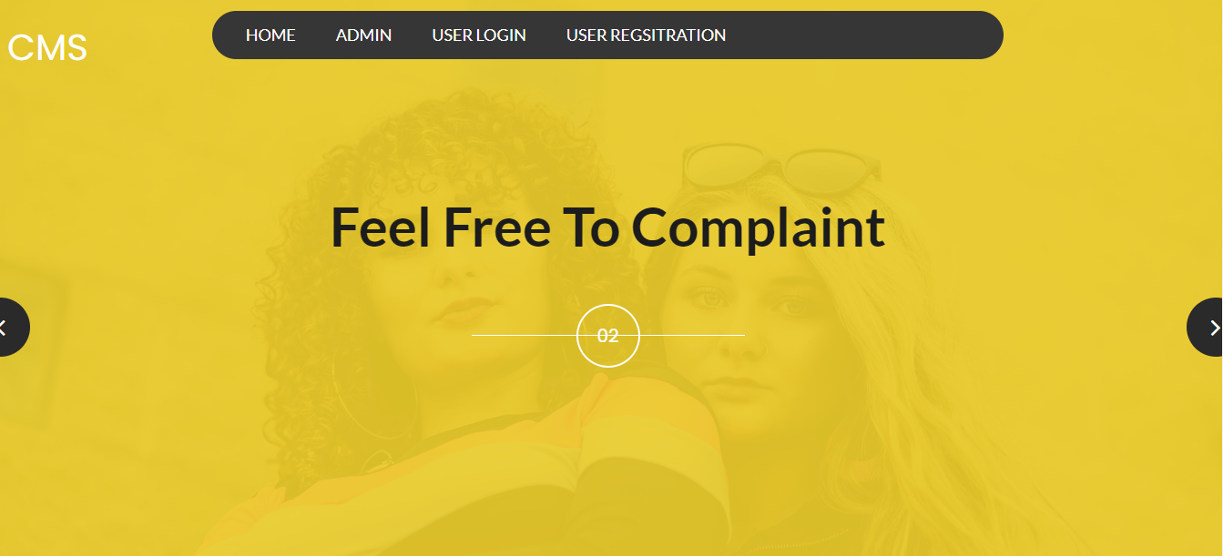

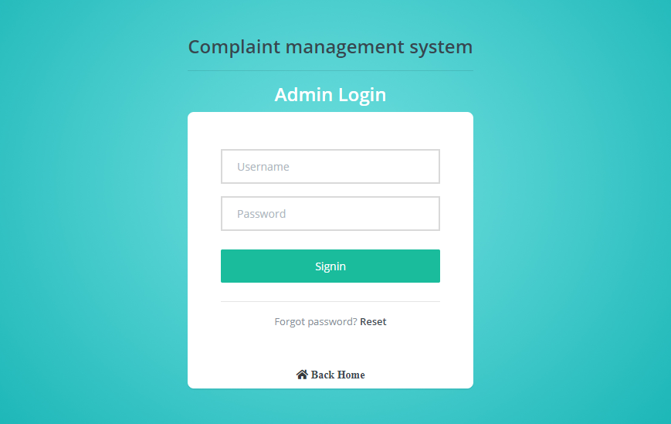

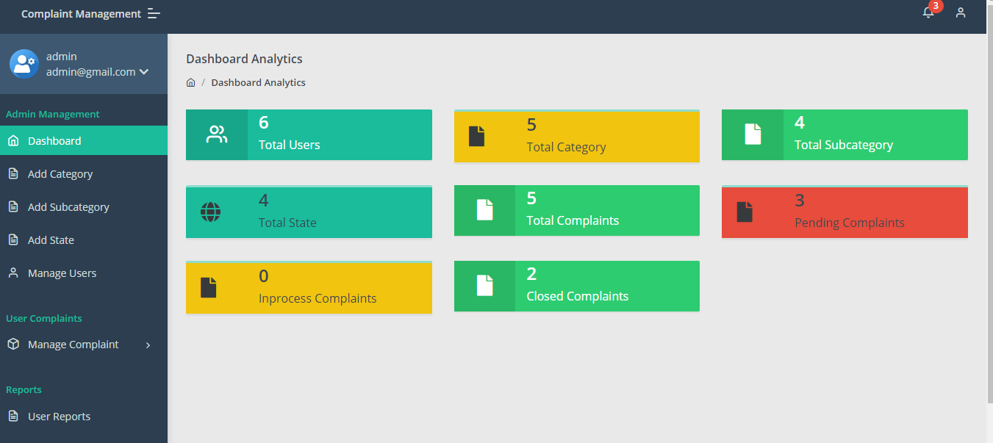

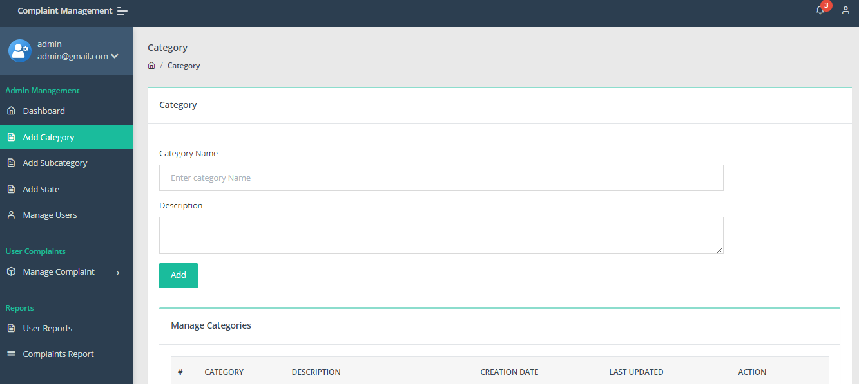

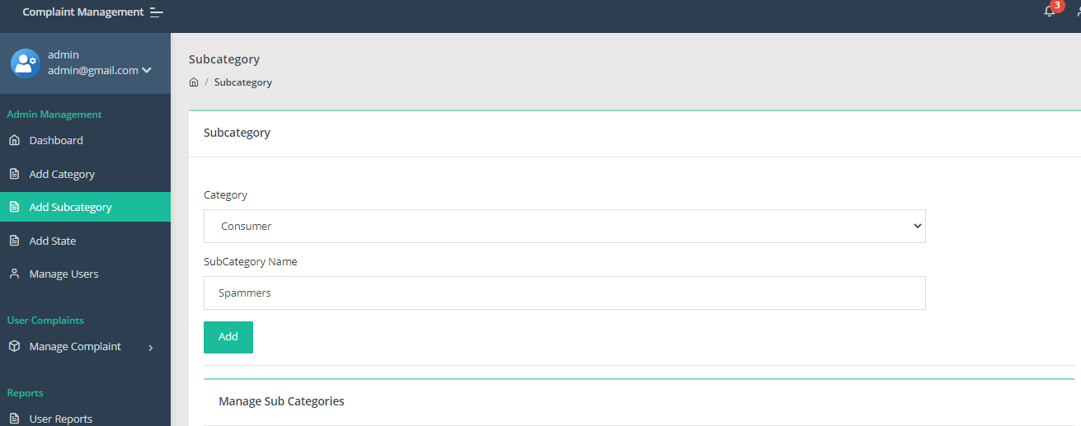

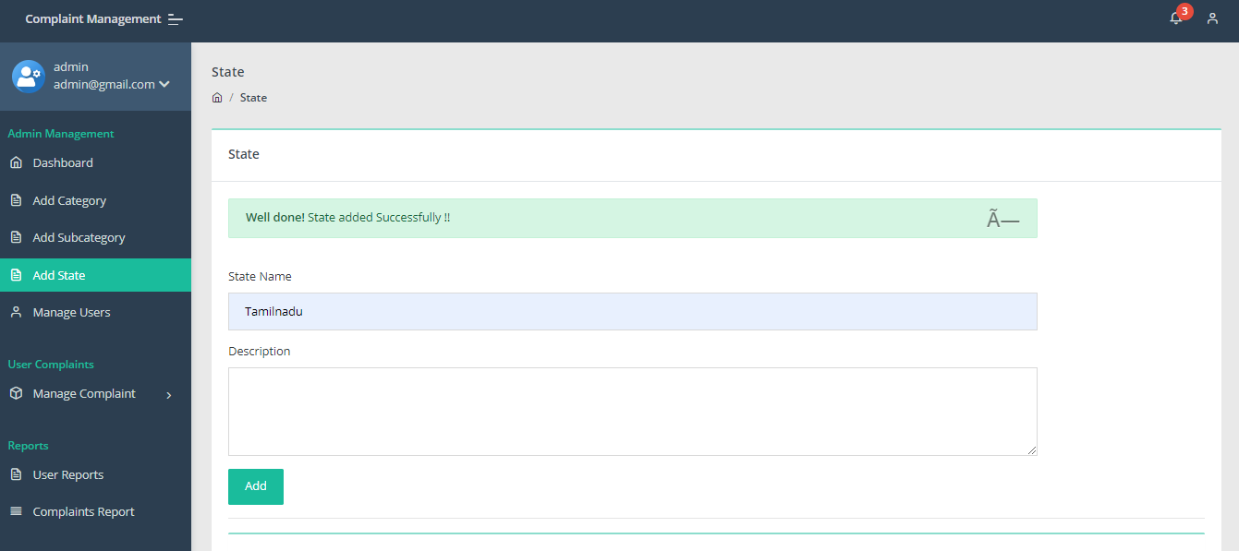

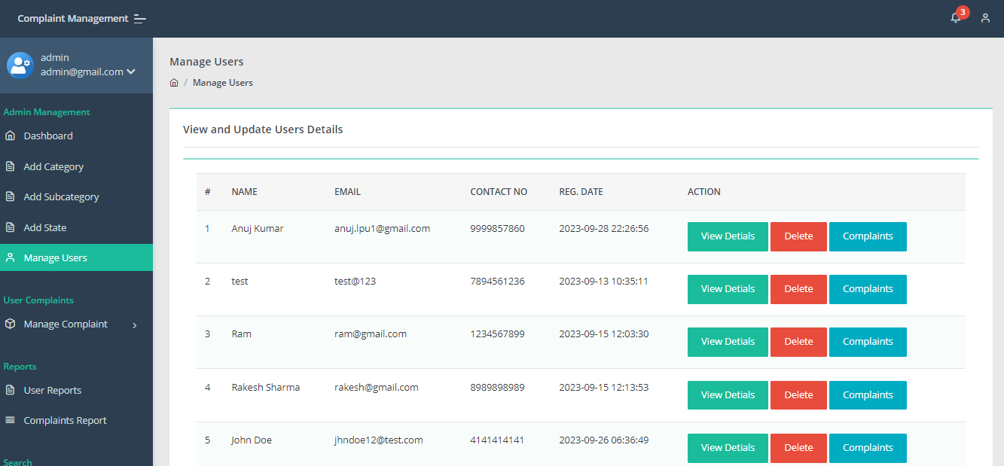

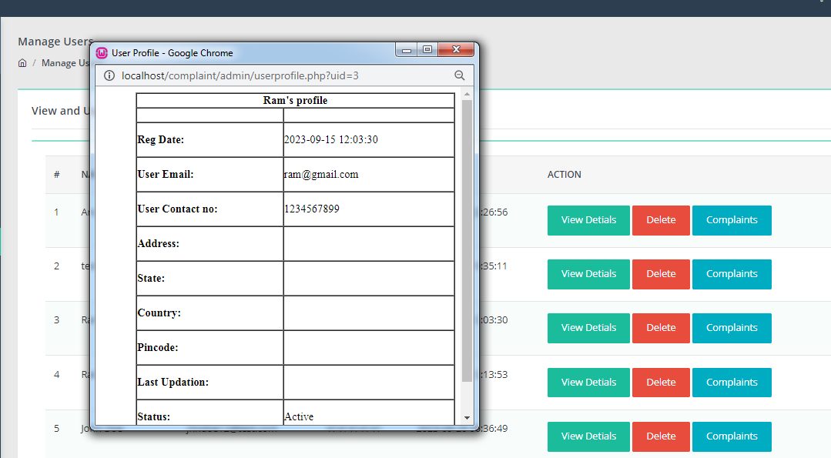

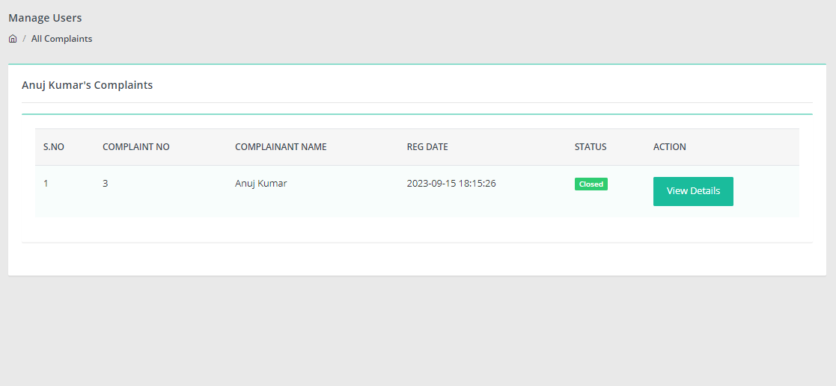

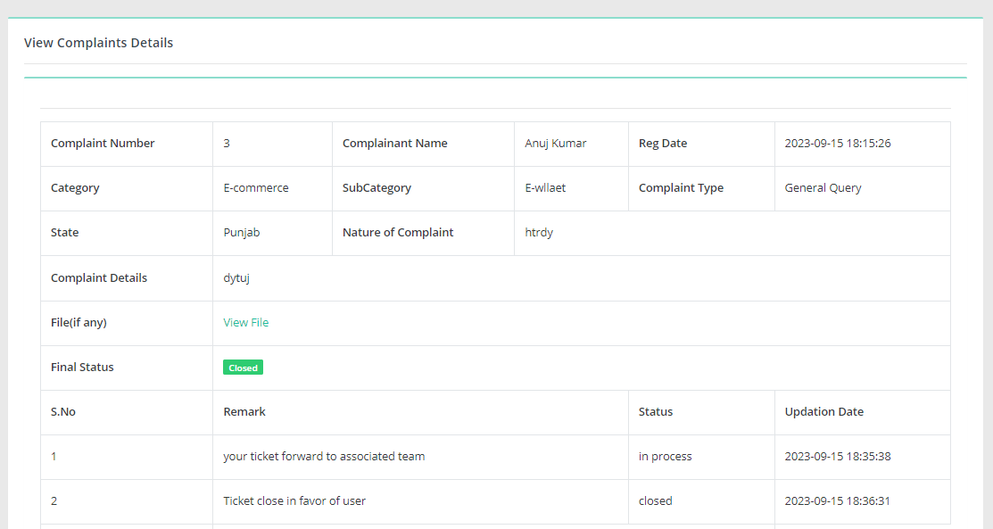

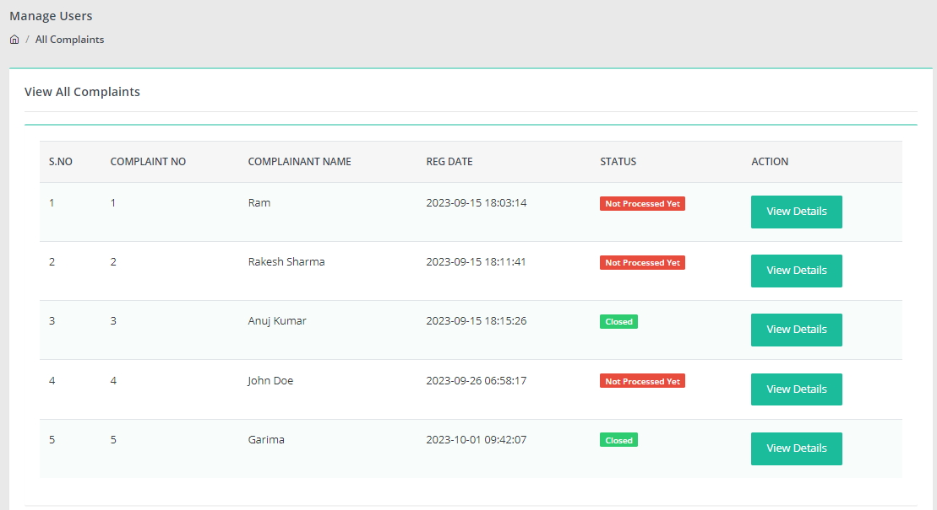

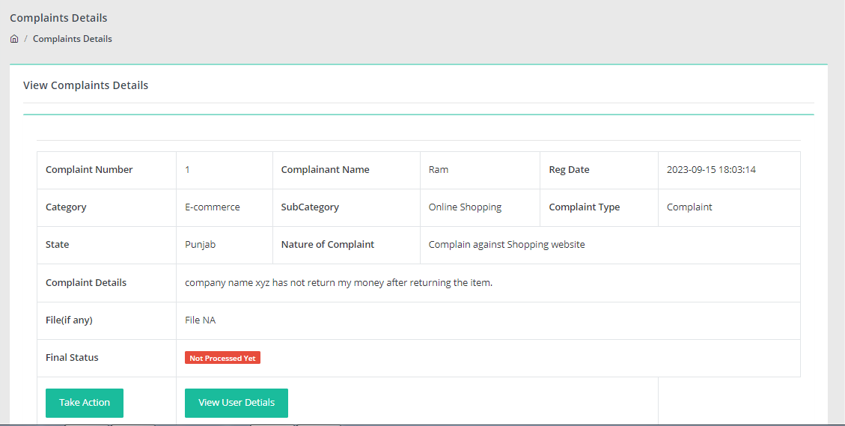

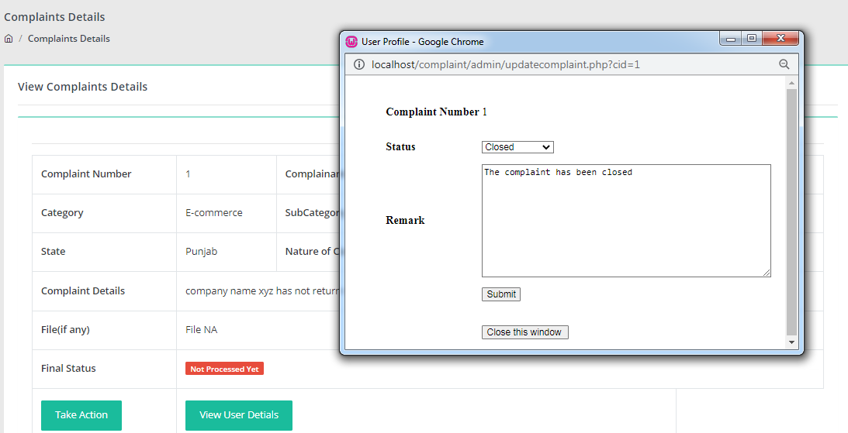

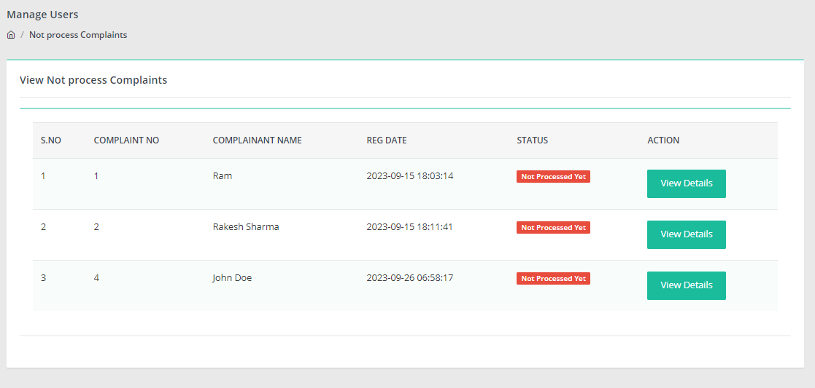

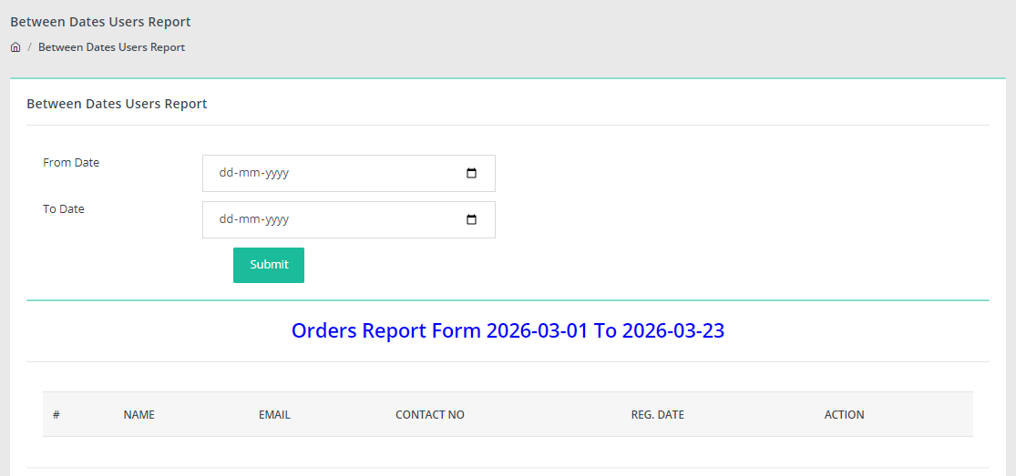

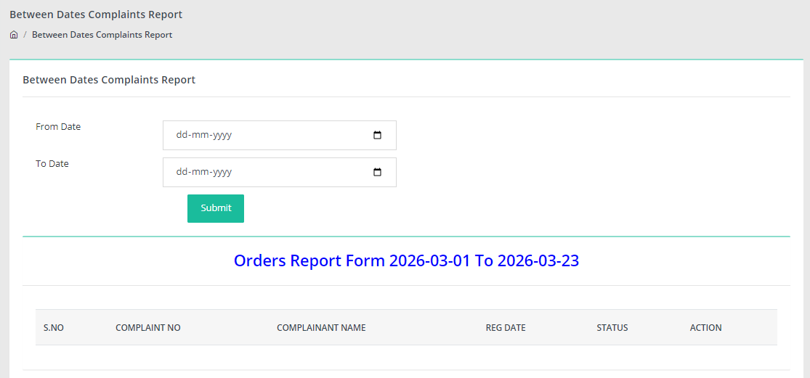

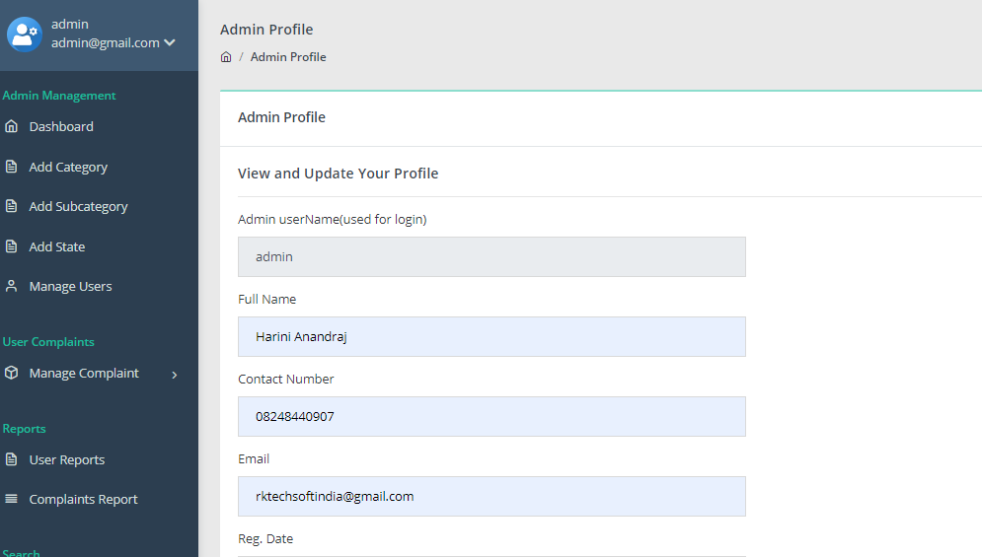

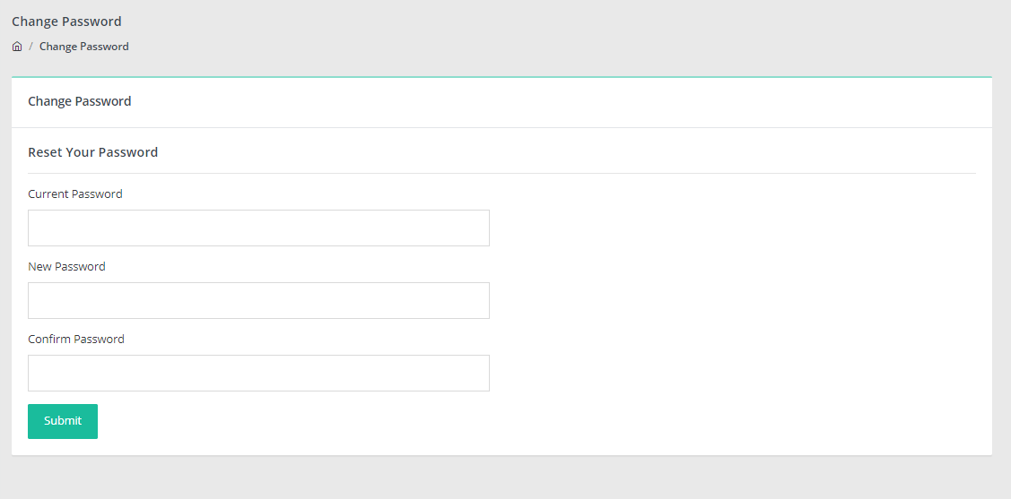

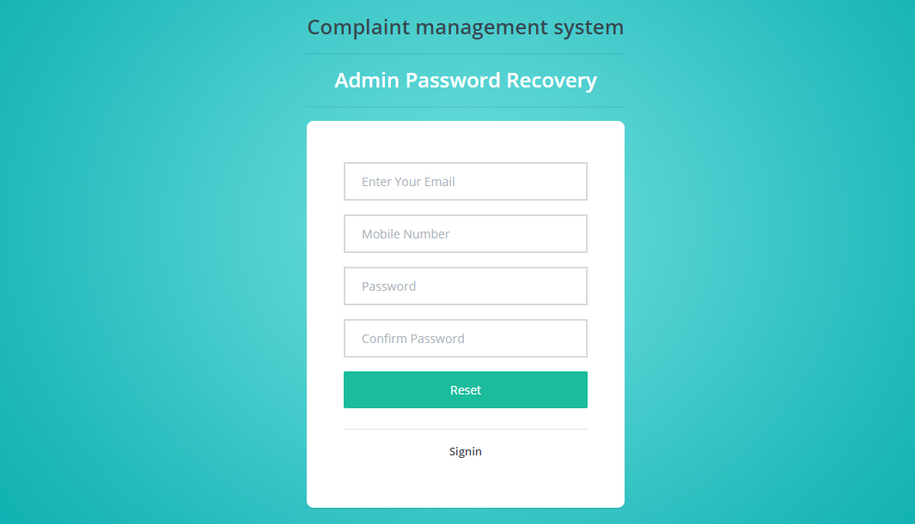

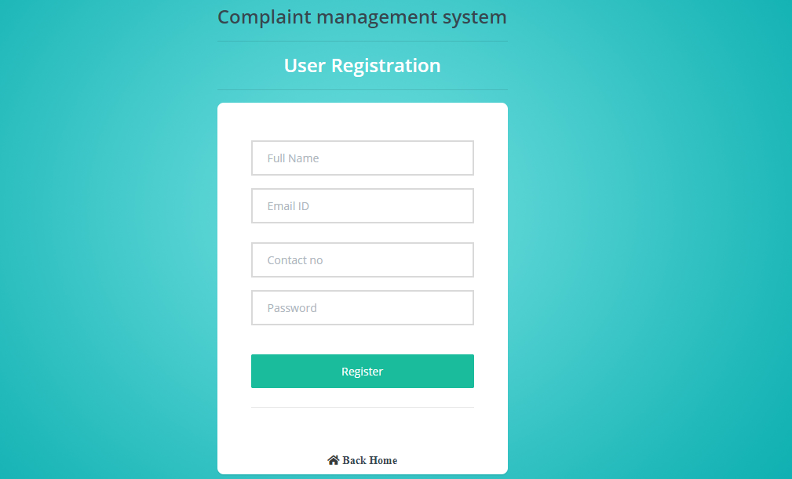

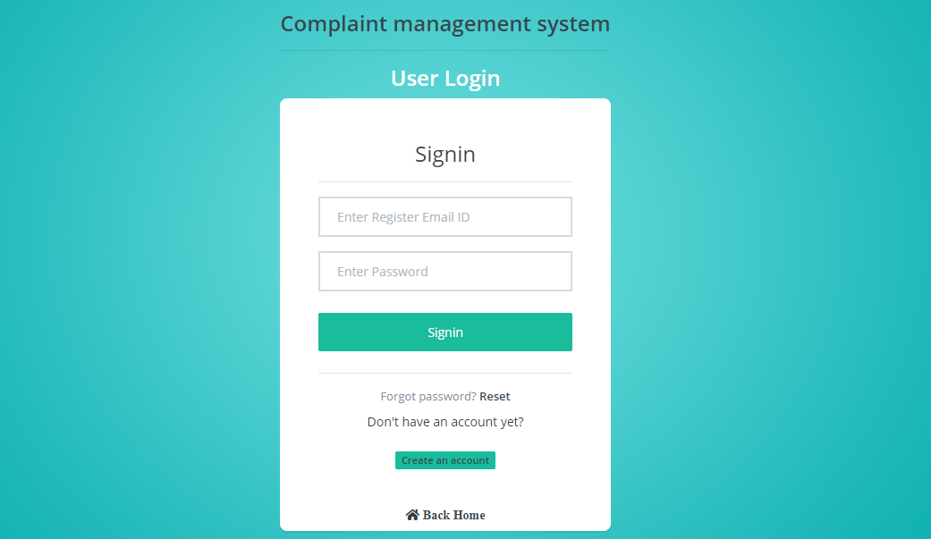

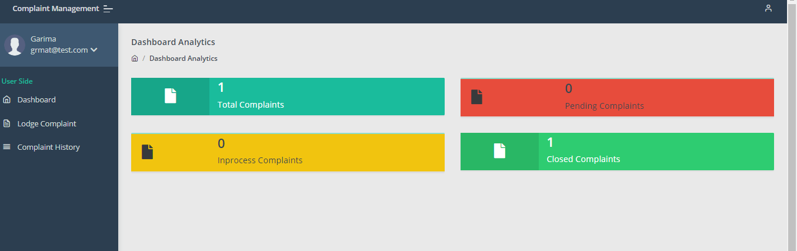

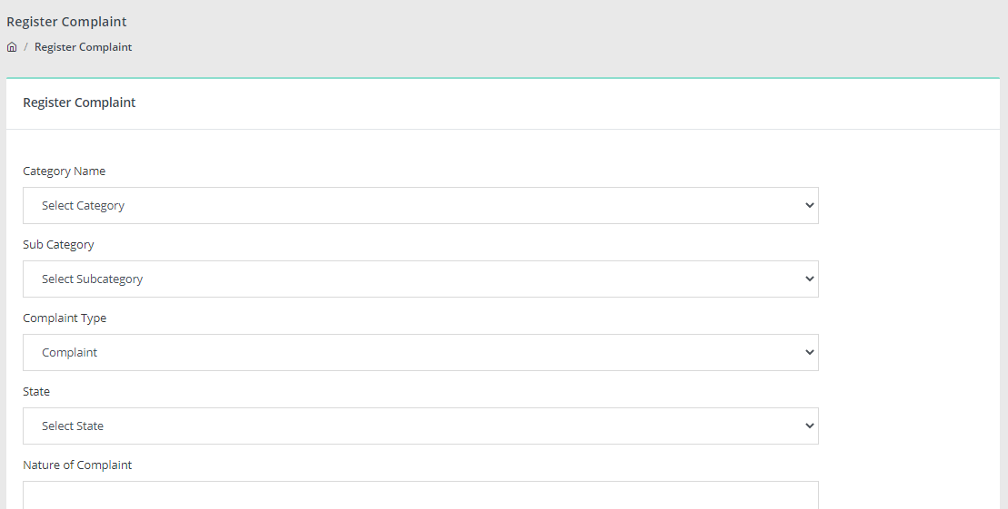

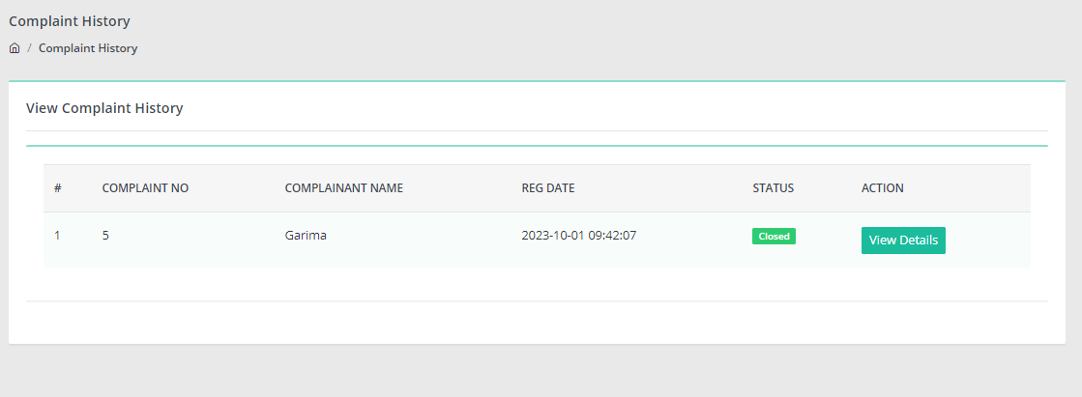

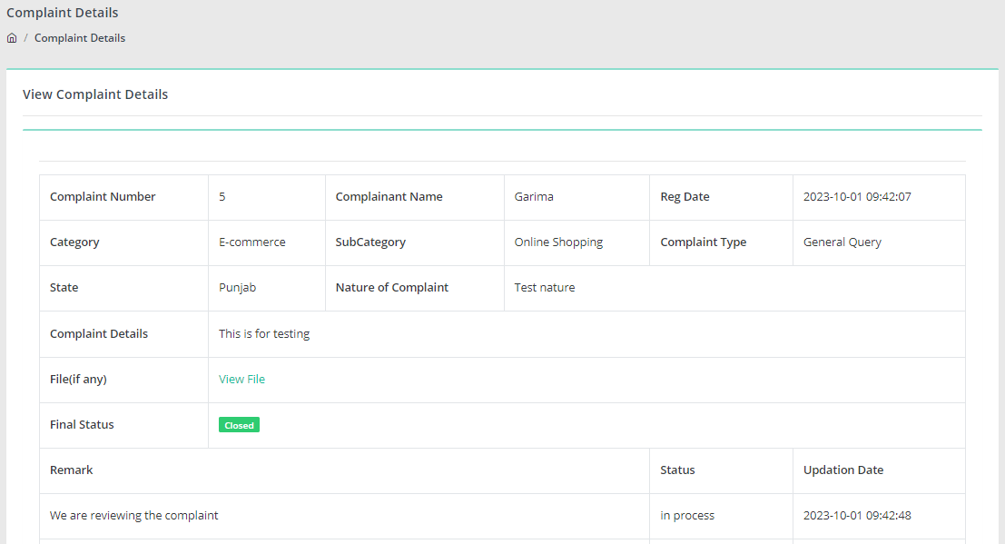

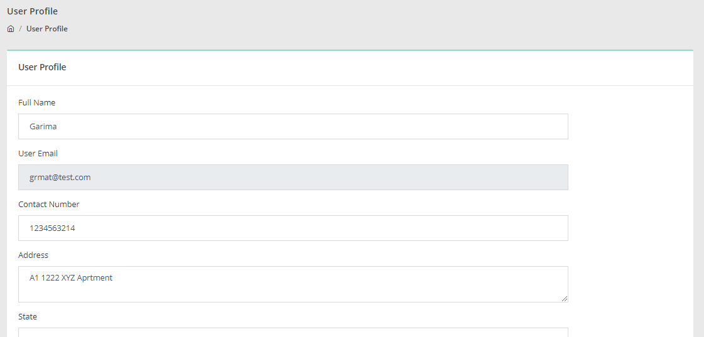

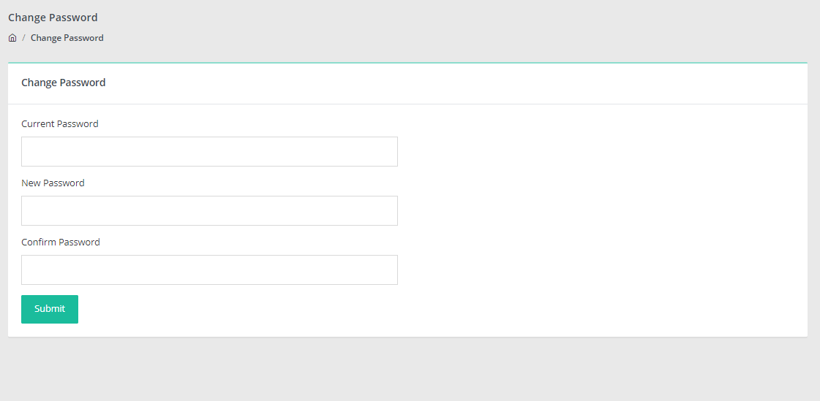

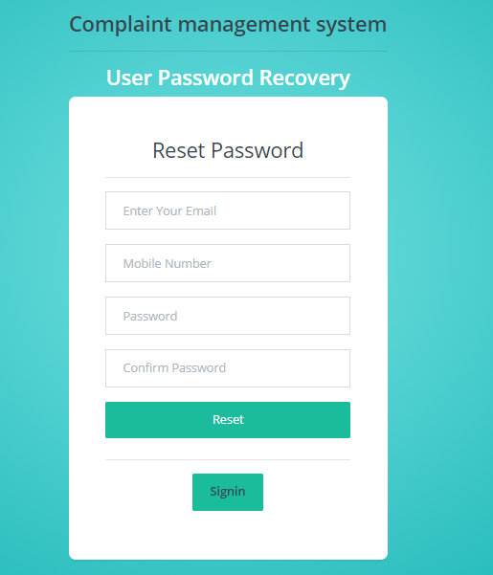

CHAPTER – 7

CONCLUSION

The Complaint Management System developed using PHP and MySQL provides an efficient and reliable solution for handling customer complaints. The system simplifies the process of complaint registration, tracking, and resolution through an easy-to-use web interface.
By automating the entire complaint handling process, the system reduces manual work, minimizes errors, and improves response time. It ensures transparency by allowing users to monitor the status of their complaints and receive timely updates. The centralized database helps in maintaining accurate records for future reference and analysis.
Overall, the system enhances communication between users and administrators, improves operational efficiency, and increases customer satisfaction. The project successfully demonstrates how technology can be used to streamline complaint management processes in an organized and effective manner.
The Complaint Management System helps in efficiently managing and resolving customer complaints through an automated process. It reduces manual work, improves transparency, and ensures faster response. Overall, the system enhances efficiency and increases customer satisfaction.

CHAPTER – 8

Reference Links & Bibliography

- Book Name : PHP 5 - Edition 2023
Author : Anne Boehm
Publication : Murcach

- Book Name : MySQL 2022
Author : Selvam, Chitra
Publication : VR1 Publications

For PHP
https://www.w3schools.com/php/default.asp
https://www.sitepoint.com/php/
https://www.php.net/

For MySQL
https://www.mysql.com/
http://www.mysqltutorial.org

For XAMPP
https://www.apachefriends.org/download.html

PHP Official Documentation – https://www.php.net/docs.php
MySQL Official Documentation – https://dev.mysql.com/doc/
W3Schools – PHP & MySQL Tutorials – https://www.w3schools.com/
TutorialsPoint – PHP and MySQL Guide – https://www.tutorialspoint.com/
MDN Web Docs (Web Development Basics) – https://developer.mozilla.org/
XAMPP Official Website – https://www.apachefriends.org/
• “Web Database Applications with PHP and MySQL” by Hugh E. Williams & David Lane

